**Deploying Private docker images to OpenShift.**

#### **Step 1 login to dockerhub**

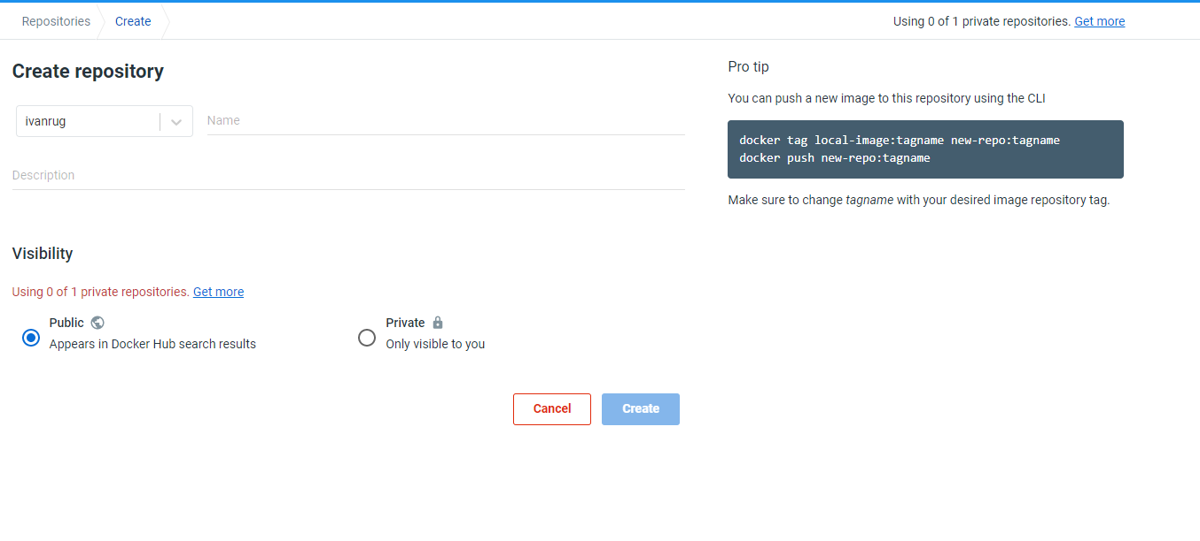

Press up on the right field on repositories and you will see the above image remember the dockerhub name .

#### **Step 2 go to your terminal and type in the following commands.**

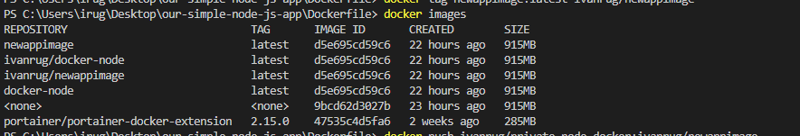

Type in “docker images” to get all names then pick one that you would like to create to a dockerhub repository. You will need existing images for this to work or you will have to create one.



Type in “docker login” to connect to Dockerhub if you get login Succeeded you have connected successfully.

## 

Here we will have to tag the image like we have done with the commands above (docker tag newappimage:latest ivanrug/newappimages) this will tag our image with our dockerhub name to create a repository.



now we can push it to dockerhub with the commands ” docker push ivanrug/newappimage”.

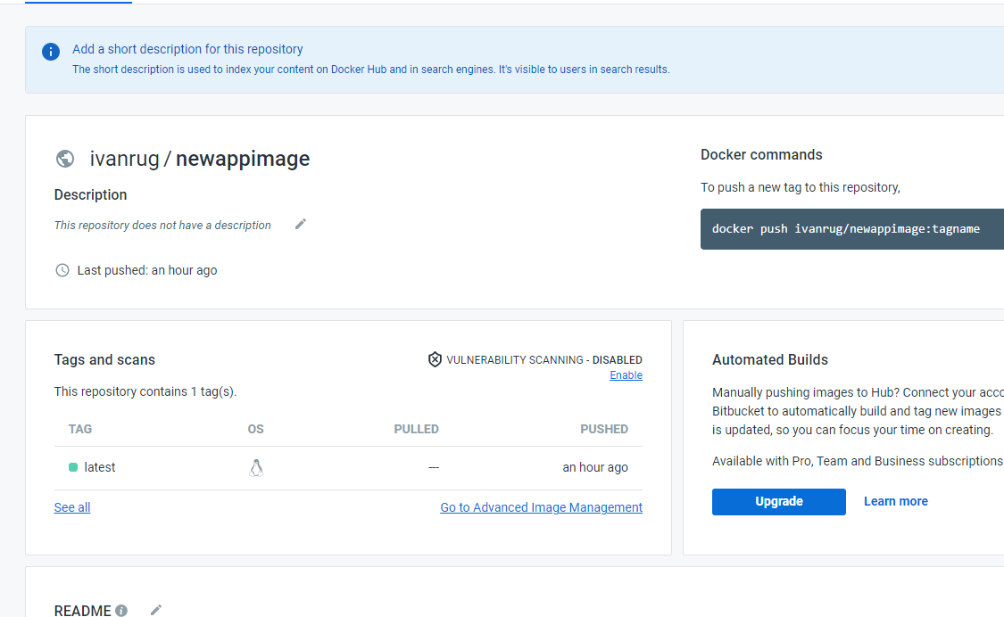

We have successfully created a repository .

#### **Step 3 login to openshift sandbox click on +add**

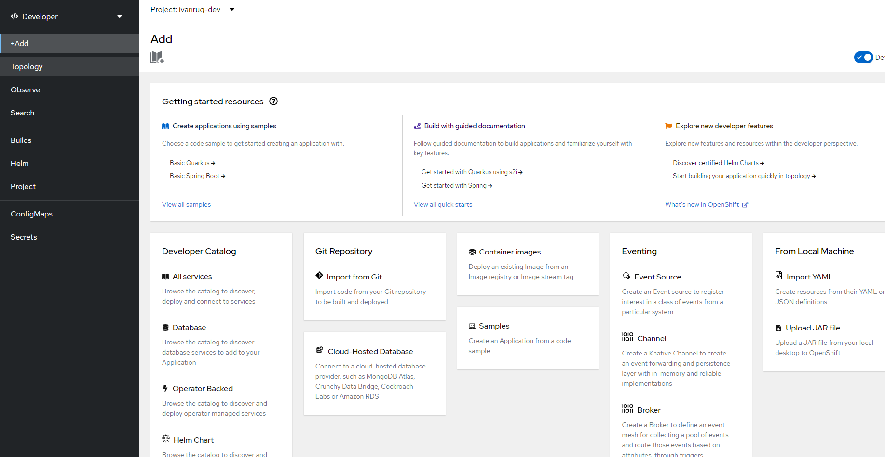

When you have clickt on ” +Add” choose container images.

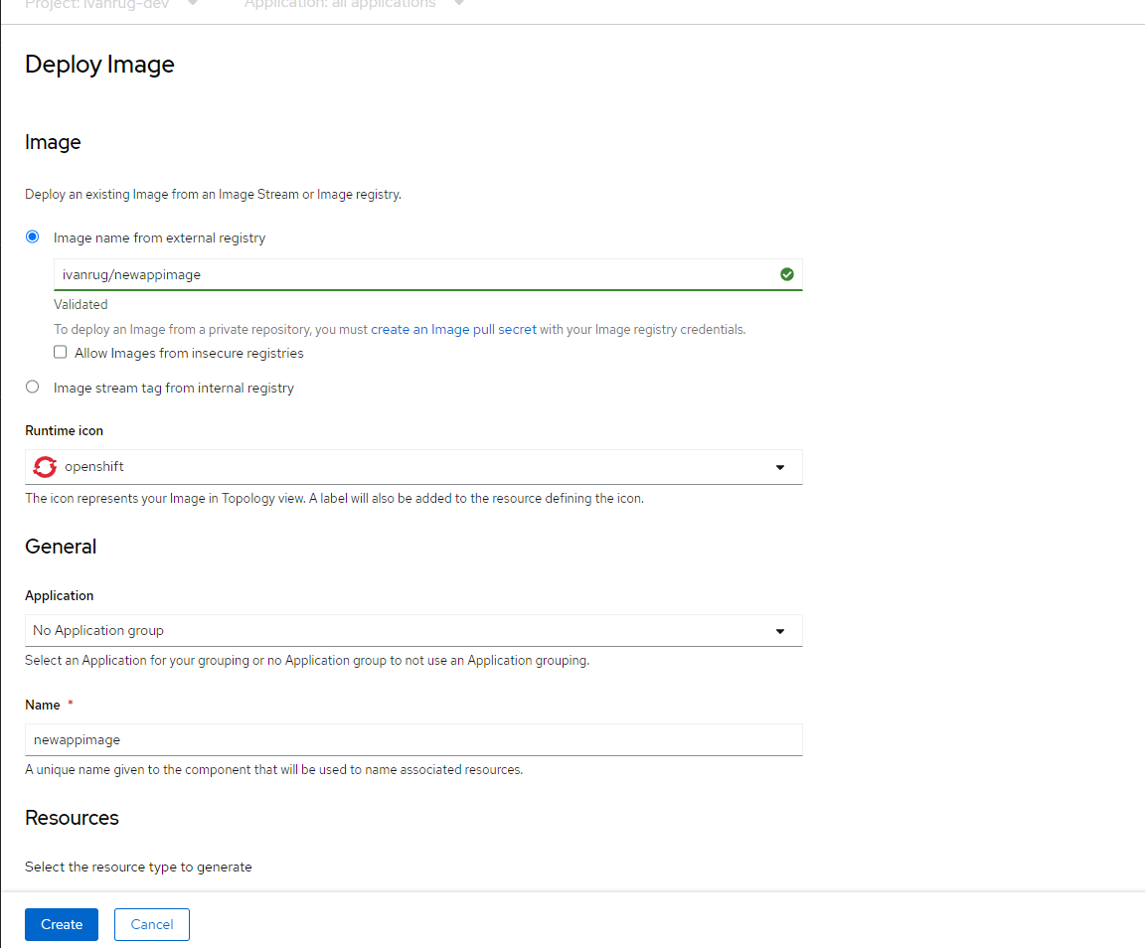

Go back to Dockerhub and copy the repository name and paste it in image name in openshift sandbox then click on create.





We have now created a pod.